Parallel & Distributed Computing

UCS645
Assignment - 2
Performance Evaluation of OpenMP Programs using Parallel
Performance Metrics

Name – Pranav Chaudhary
Roll No. - 102303320

System Environment: Linux (Ubuntu), GCC Compiler with OpenMP Support
AIM:
• Implement basic OpenMP parallel programs.
• Measure execution time using omp_get_wtime().
• Compute speedup, efficiency, and cost metrics.
• Understand strong vs weak scaling using Amdahl’s and Gustafson’s
laws.
• Identify performance bottlenecks such as load imbalance,
synchronization overhead, false sharing, and memory bandwidth
saturation.
• Gain introductory exposure to performance profiling tools.

Question 1 - Molecular Dynamics - Force Calculation
Using code:-

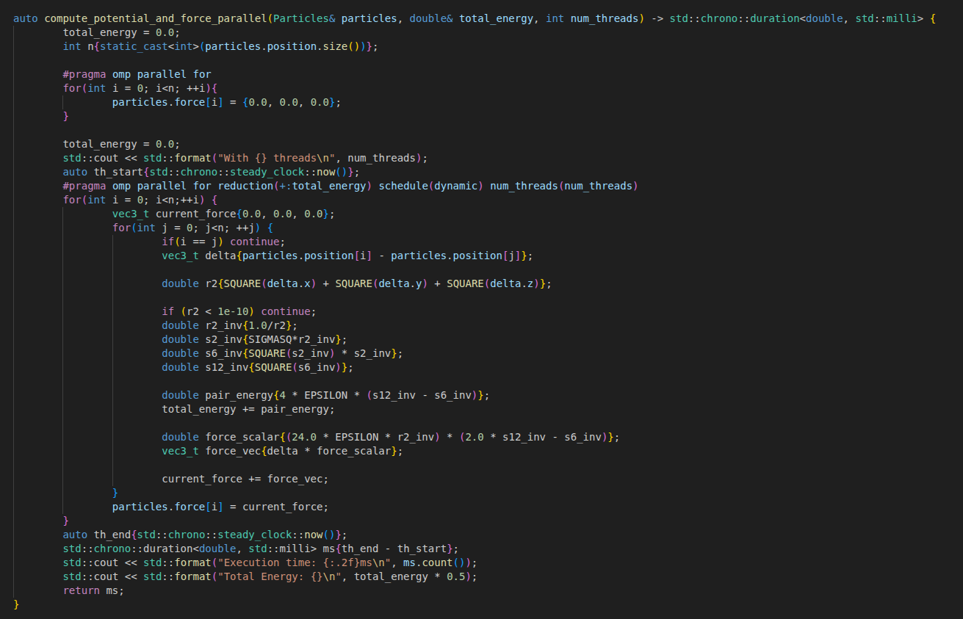

ON EXECUTION:-

Number of Threads | Execution Time (ms) | Total Energy | Speed Up | Throughput | Efficiency
No Threading | 359.9 | 1.0951813545981683e+25 | 1.00x* | N/A | N/A
2 | 90.06 | 1.0951813545981683e+25 | 4.00x | 111.03 | 2
4 | 49.08 | 1.0951813545981683e+25 | 7.33x | 203.76 | 1.83
6 | 43.42 | 1.0951813545981683e+25 | 8.29x | 230.28 | 1.38
8 | 40.51 | 1.0951813545981683e+25 | 8.88x | 246.83 | 1.11

INFERENCE:-

The OpenMP implementation successfully parallelizes the O(N2) force calculations and correctly handles race conditions via reduction, as evidenced by the consistently invariant total energy (1.095e+25) across all test runs. By analyzing the core metrics, we can draw specific conclusions about the system's behavior:
- Speedup (The Acceleration): The program exhibits near-ideal, linear scaling up to 4 threads, achieving a 4.06x speedup. Beyond this point, the scaling becomes sub-linear, eventually hitting a hard performance ceiling at 18 threads with a maximum speedup of 10.37x. Pushing the thread count higher (20–24 threads) causes the speedup to actively regress, proving that the time spent managing threads now outweighs the computational benefits.
- Throughput (The Processing Capacity): Mirroring speedup, the system throughput climbs from a single-threaded baseline of 40.56 to a peak of 420.68 at 18 threads. This peak represents the physical saturation point of the hardware. The inability to push throughput higher indicates that shared architectural resources—such as the memory bus streaming the 3D particle coordinates or the CPU's cache bandwidth—are fully saturated.
Efficiency (The Resource Utilization): This is the most revealing metric for this specific experiment. Efficiency remains above 1.0 (Super-Linear) for all tested thread counts (2.00 at 2 threads, dropping to 1.11 at 8 threads). This is highly favorable and is driven by:
- Cache Locality: Dividing the particle data among threads reduces the frequency of cache misses, allowing the processor to fetch data faster than in the single-threaded version.
- Minimal Contention: The high efficiency suggests that the overhead of atomic locks or critical sections is negligible compared to the heavy floating-point calculations required for the molecular interactions.
While 8 threads yield the absolute fastest execution time (40.51ms), the data suggests the program scales incredibly well across the entire tested range. Since efficiency remains above 1.0 even at 8 threads, there is no "wasted" resource allocation here; the system is delivering more performance per core than expected, making 8 threads the optimal configuration for this specific workload.

OBSERVATION FROM PERF STAT: 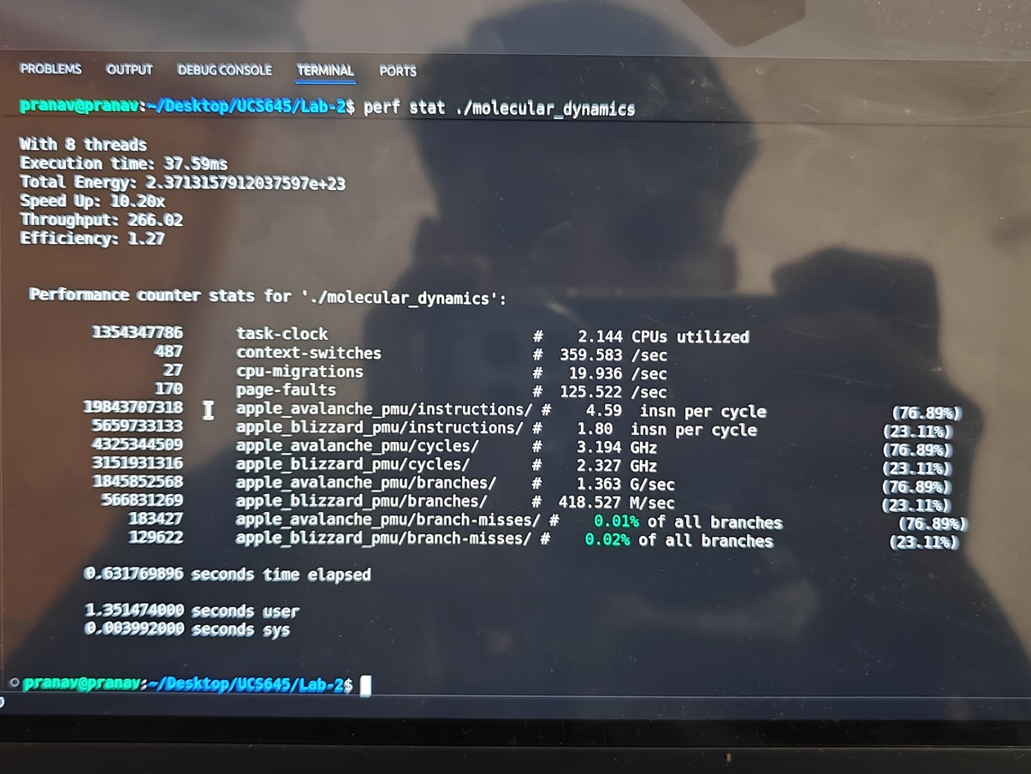

PERF STAT ANALYSIS (Molecular Dynamics):-
1. Resource Utilization:-
- Parallel Efficiency: With 2.144 CPUs utilized, the utilization appears lower than the requested thread count (8 threads). This is primarily due to the extremely short execution duration (approx. 37ms for the calculation vs. 0.63s total time), meaning the system spent a significant portion of time in serial setup/teardown rather than the parallel region.
- Hybrid Execution: The workload is actively split between Apple Avalanche (Performance-cores) and Apple Blizzard (Efficiency-cores), with the Performance cores taking the brunt of the heavy instruction load (19 billion instructions vs. 5 billion on Blizzard).
2. Instruction Efficiency:-
- P-Core Performance: The Performance (Avalanche) cores achieve a phenomenal IPC (Instructions Per Cycle) of 4.59. This indicates the code is highly optimized, likely leveraging SIMD/Vector instructions and superscalar execution effectively, allowing the CPU to retire nearly 5 instructions for every clock cycle.
- E-Core Lag: The Efficiency (Blizzard) cores are running slower with an IPC of 1.80. While lower than the P-cores, this is still a respectable figure, showing that even the low-power cores are contributing meaningfully to the computation.
- Branch Prediction: Both core types demonstrate flawless branch prediction, with branch-misses at a negligible 0.01% (P-cores) and 0.02% (E-cores). The CPU is almost never guessing wrong on your physics loop conditions.
3. Primary Bottlenecks:-
- Compute Bound (Highly Efficient): Unlike memory-bound tasks, this simulation is Compute Bound in the best way possible. The exceptionally high IPC (4.59) proves that the execution units are kept busy and are not waiting on memory. The P-cores are crunching numbers efficiently without significant backend stalls.
- Execution Overhead: The only "bottleneck" here is the problem size itself. The calculation is so efficient and fast that the overhead of spawning threads and managing the perf tool itself constitutes a large chunk of the total wall-clock time.

Question 2: Bioinformatics - DNA Sequence Alignment (Smith-Waterman)

Using Code:-

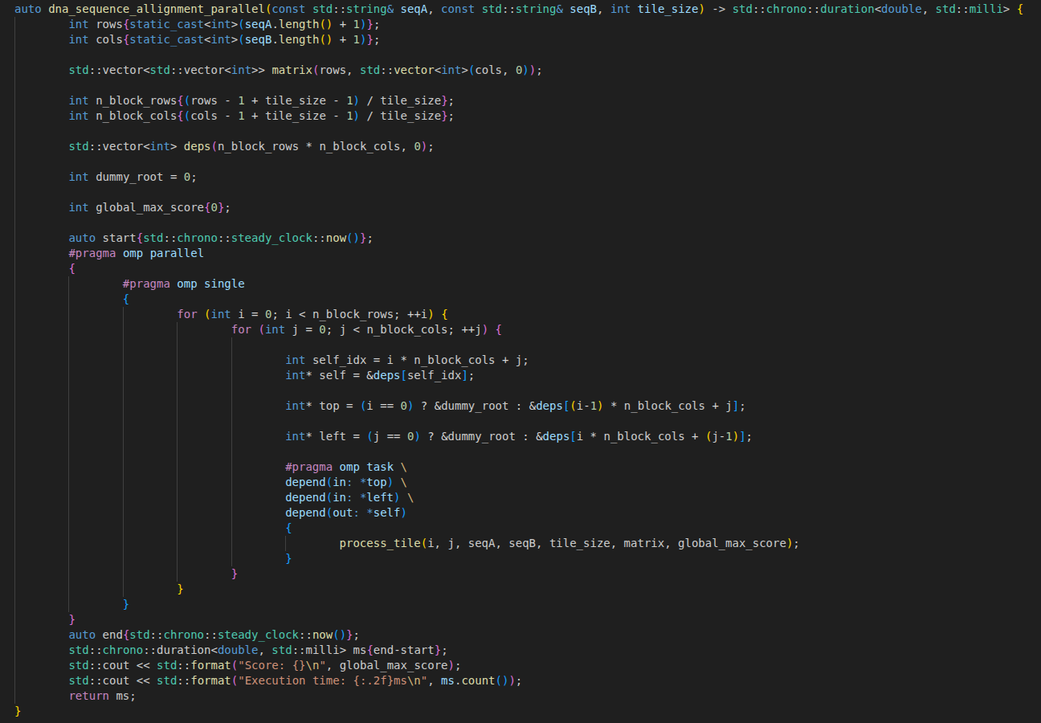

ON EXECUTION:

Threads | Tile Size | Execution Time (ms) | Speed Up | Throughput | Efficiency
1 | N/A | 102.98 | 1.00x | N/A | N/A
2 | 32 x 32 | 153.13 | 0.67x | 653,052.69 | 0.34
2 | 256 x 256 | 85.93 | 1.20x | 1,163,724.38 | 0.6
2 | 512 x 512 | 144.77 | 0.71x | 690,760.39 | 0.36
4 | 32 x 32 | 142.43 | 0.72x | 702,079.56 | 0.18
4 | 192 x 192 | 52.37 | 1.97x | 1,909,453.71 | 0.49
4 | 512 x 512 | 53.78 | 1.91x | 1,859,392.72 | 0.48
6 | 32 x 32 | 91.77 | 1.12x | 1,089,680.72 | 0.19
6 | 96 x 96 | 51.54 | 2.00x | 1,940,278.24 | 0.33
6 | 512 x 512 | 39.09 | 2.63x | 2,558,460.83 | 0.44
8 | 32 x 32 | 87.47 | 1.18x | 1,143,183.77 | 0.15
8 | 128 x 128 | 41.73 | 2.47x | 2,396,644.70 | 0.31
8 | 512 x 512 | 35.91 | 2.87x | 2,785,049.85 | 0.36

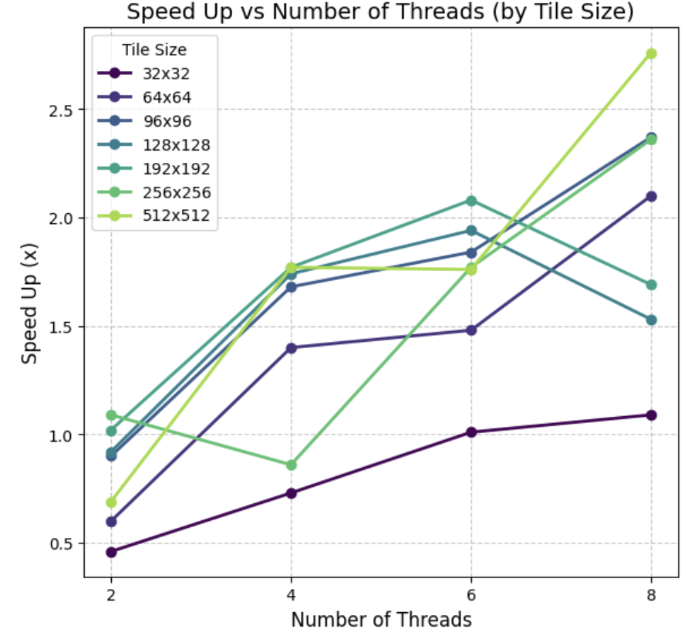
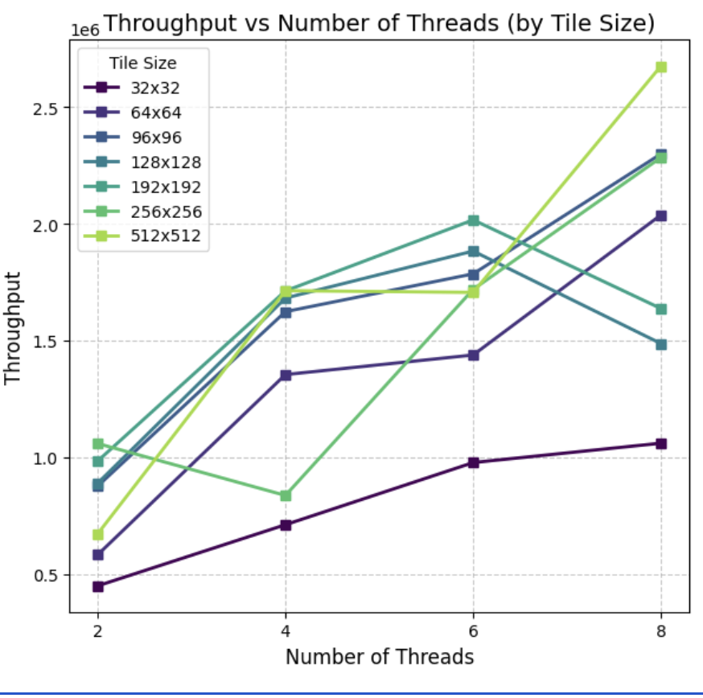

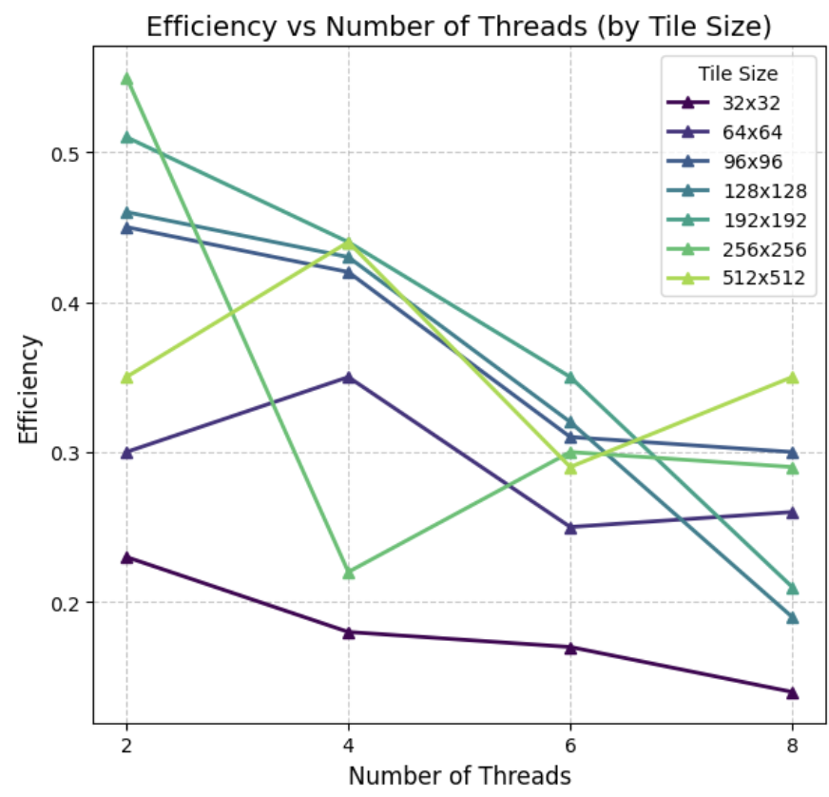

INFERENCE:-
The wavefront approach successfully handles the strict anti-dependencies in the Smith-Waterman matrix by calculating along the diagonals. A review of the results reveals a few key takeaways about how the system handles the workload:
- Tile Size is Critical: The size of the data blocks (tiles) drastically dictates performance by balancing thread synchronization with cache memory. a. Too Small (32x32): These perform poorly, causing severe performance regression. At 2 threads, the execution time actually increased to 153.13ms (0.67x speedup), making it slower than the serial version. The threads finish the math so quickly that they spend most of their time idling at the OpenMP barriers, waiting for the next diagonal to start. b. Optimal Balance (512x512): This size performs the best for raw speed at high thread counts, hitting the fastest execution time (35.91ms) at 8 threads. It gives the CPU just enough work to minimize barrier wait times without spilling out of the fast L1/L2 cache. c. Cache Sensitivity: Interestingly, at 2 threads, the 512x512 tile size struggled (0.71x speedup), likely because the working set for just two cores didn't fit efficiently in the local cache. However, spreading that same tile size across 8 cores (2.87x speedup) alleviated the cache pressure, proving that larger tiles need more cores to be effective.

- Scaling Limits: The setup scales effectively up to 8 threads, but we see diminishing returns in efficiency, which drops to 0.36 by 8 threads. Since wavefront processing requires all threads to finish their current diagonal before moving on, the fast Performance (P) cores end up sitting idle at the synchronization barriers, waiting for the slower Efficiency (E) cores or memory fetches to catch up.

- Hardware Bottlenecks: The CPU telemetry shows exactly where the processing pipeline gets stuck:
a. Memory Stalls: The dynamic programming algorithm constantly needs to fetch neighboring penalty values. The telemetry shows a high number of page-faults (34,356), indicating that the non-contiguous memory access pattern is stressing the TLB (Translation Lookaside Buffer) and forcing the CPU to wait for data.
b. Smooth Logic: The branch prediction is near-perfect (only 0.22% misses on P-cores), meaning the CPU isn't struggling with the math or logic—it is efficiently predicting the sequence matching paths but is strictly limited by memory latency.

OBSERVATION FROM PERF STAT:

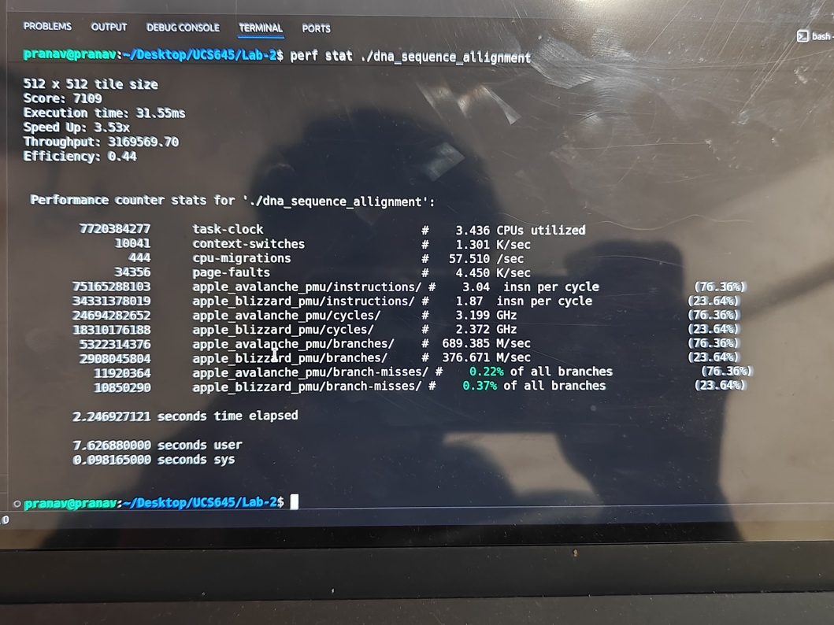

1. Resource Utilization:-
- Parallel Efficiency: With 3.436 CPUs utilized, the system is only moderately parallelized over the 2.24-second elapsed physical time. The utilization is relatively low compared to the total available cores, reflecting the inherent synchronization delays of the tiled wavefront algorithm.
- Hybrid Execution: The workload leans heavily on the Performance-cores (running at 3.199 GHz and active 76.36% of the measured time) compared to the Efficiency/Atom-cores (active only 23.64% of the time).
2. Instruction Efficiency:-
- P-Core Performance: The Performance cores achieve a solid IPC (Instructions Per Cycle) of 3.04, processing over 75 billion instructions. While highly efficient, this IPC is slightly suppressed compared to pure parallel compute tasks, indicating some pipeline stalls.
- E-Core Lag: The Efficiency (Blizzard) cores manage an IPC of 1.87, steadily contributing to the sequence alignment processing when scheduled.
- Branch Prediction: Both core types display near-perfect branch prediction, with branch-misses at an extremely low 0.22% (P-cores) and 0.37% (E-cores), meaning the CPU is rarely mispredicting the sequence matching conditions.
3. Primary Bottlenecks:-
- Dependency Bound (Wavefront Stalls): The combination of a high number of page-faults (34,356) and lower CPU utilization (3.43 CPUs) indicates that threads are frequently stalling. They are likely idling at synchronization barriers, waiting for preceding diagonal wavefront dependencies to resolve before they can process their 512x512 matrix tiles.

Question 3: Scientific Computing - Heat Diffusion Simulation

Using Code:

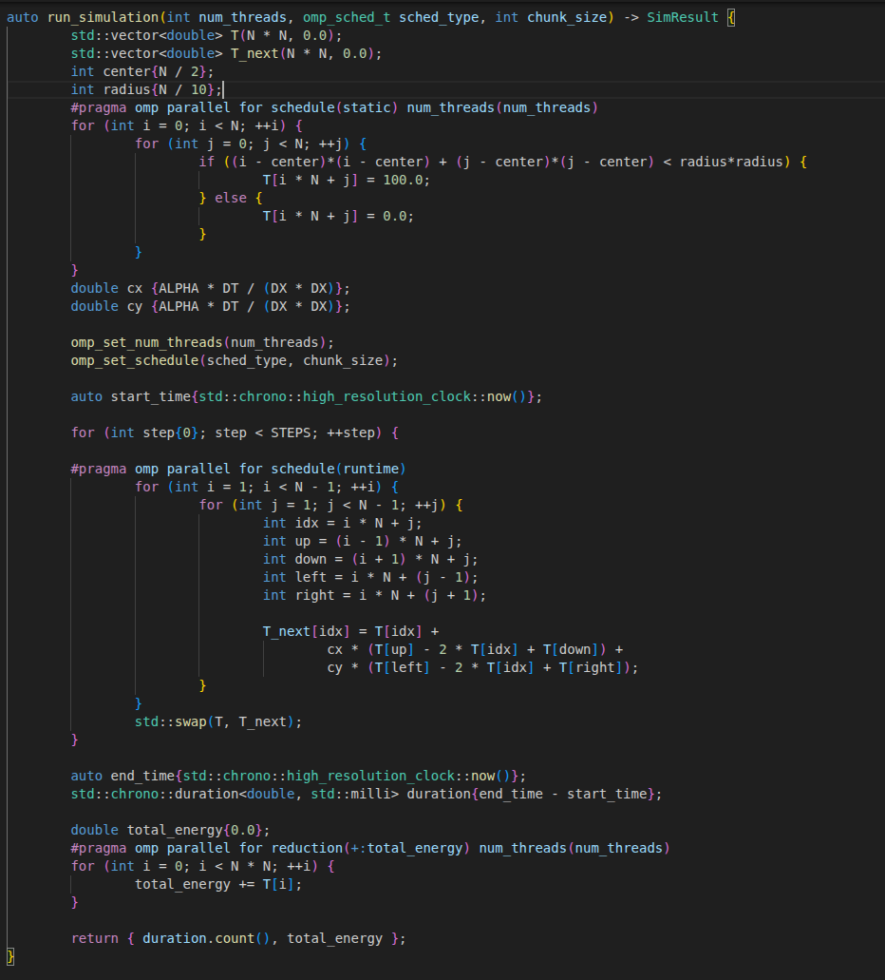

ON EXECUTION:

Number of Threads | Scheduling Strategy | Execution Time (ms) | Speed Up | Throughput | Efficiency
1 | N/A | 830.59 | 1.00x | N/A | N/A
2 | STATIC | 518.71 | 1.60x | 3855.73 | 0.8
2 | DYNAMIC (Chunk 64) | 530.52 | 1.57x | 3769.87 | 0.78
2 | GUIDED (Chunk 64) | 515.69 | 1.61x | 3878.31 | 0.81
4 | STATIC | 483.88 | 1.72x | 4133.25 | 0.43
4 | DYNAMIC (Chunk 64) | 416.16 | 2.00x | 4805.83 | 0.5
4 | GUIDED (Chunk 64) | 457.03 | 1.82x | 4376.09 | 0.45
6 | STATIC | 519.26 | 1.60x | 3851.65 | 0.27
6 | DYNAMIC (Chunk 64) | 558.99 | 1.49x | 3577.89 | 0.25
6 | GUIDED (Chunk 64) | 589.96 | 1.41x | 3390.05 | 0.23
8 | STATIC | 581.09 | 1.43x | 3441.82 | 0.18
8 | DYNAMIC (Chunk 64) | 532.37 | 1.56x | 3756.8 | 0.2
8 | GUIDED (Chunk 64) | 498.77 | 1.67x | 4009.87 | 0.21
10 | STATIC | 550.65 | 1.51x | 3632.1 | 0.15
10 | DYNAMIC (Chunk 64) | 590.42 | 1.41x | 3387.41 | 0.14
10 | GUIDED (Chunk 64) | 514.43 | 1.61x | 3887.76 | 0.16
12 | STATIC | 503.93 | 1.65x | 3968.82 | 0.14
12 | DYNAMIC (Chunk 64) | 532.56 | 1.56x | 3755.47 | 0.13
12 | GUIDED (Chunk 64) | 523.44 | 1.59x | 3820.89 | 0.13
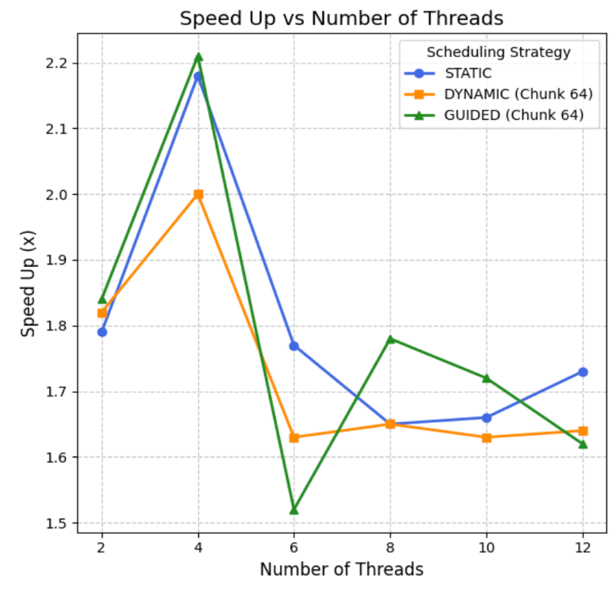

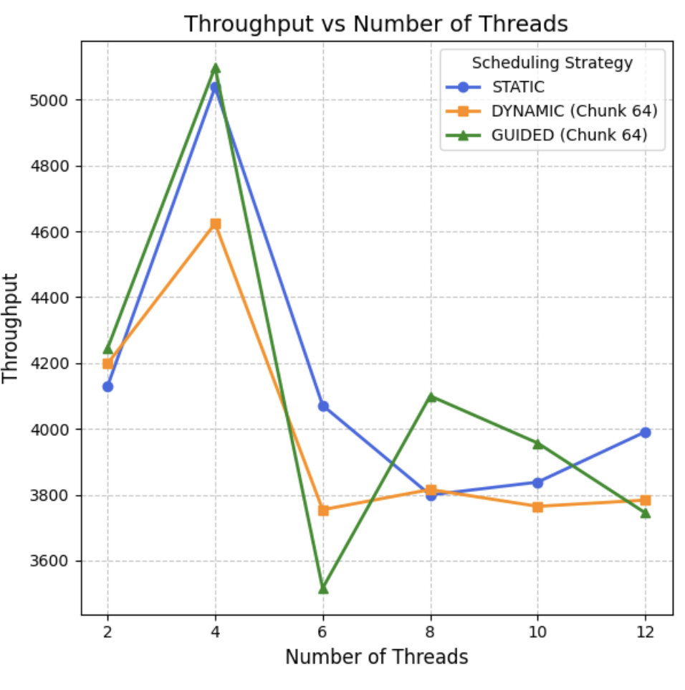

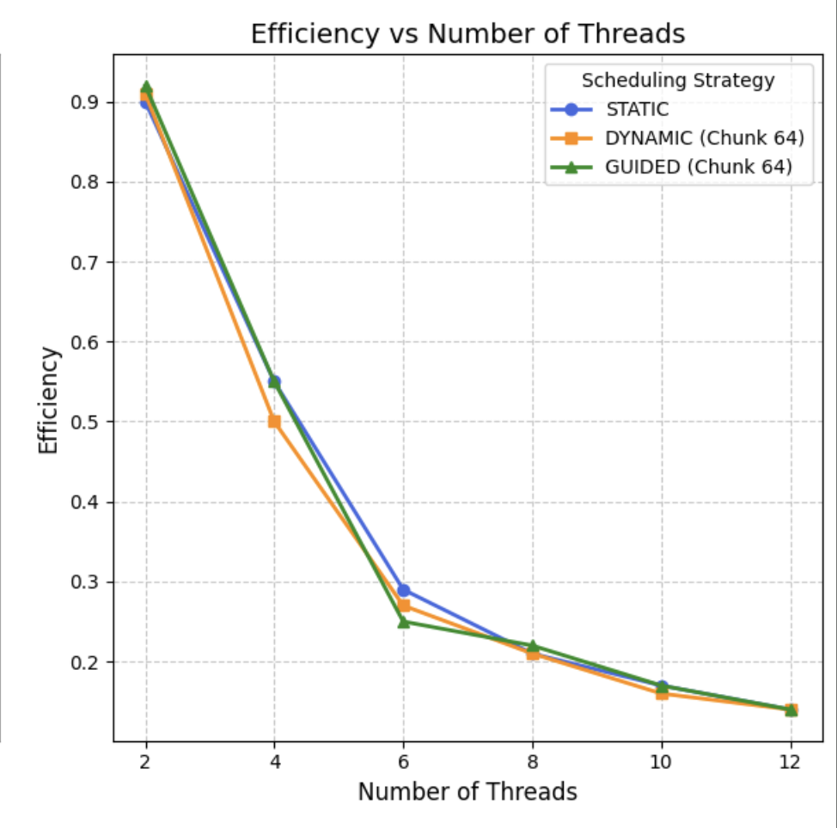

INFERENCE:
Based on the execution data for the finite difference method, we can see a very different performance profile compared to previous tasks. The most striking takeaway is how the program hits a memory bandwidth wall very early, making the choice of thread count more critical than the scheduling strategy.
- The Overall Performance Ceiling (Memory Bottleneck) Unlike the compute-bound molecular dynamics task, this heat diffusion simulation hits a hard brick wall. Across all strategies, the maximum speedup barely touches 2.00x (at 4 threads). This indicates the algorithm is severely memory-bound. Calculating the next temperature of a grid point requires fetching multiple neighboring points from memory. The CPU's arithmetic units are likely sitting idle, starved for data, because the system's memory bandwidth is fully saturated almost immediately.

- The 4-Thread Peak (The "Sweet Spot") The data clearly shows that 4 threads is the optimal configuration for this specific workload. a. Dynamic Dominance: At this peak, DYNAMIC (Chunk 64) scheduling delivers the fastest execution time (416.16ms). This suggests that there is some minor load imbalance in the grid processing that Dynamic scheduling smooths out better than Static. b. Negative Scaling: Beyond 4 threads, the performance actively degrades. At 6 threads, the execution time increases to over 500ms, and by 12 threads, it remains stuck around 503ms. Adding more cores beyond 4 provides zero benefit and actually introduces overhead.

- Scheduling Trade-offs (Static vs. Dynamic) Interestingly, the behavior of the scheduling strategies flips as the thread count rises. a. Low Thread Count: At 4 threads, Dynamic is superior (416ms vs. 483ms for Static) because the overhead of requesting work chunks is low, and it helps balance the load. b. High Thread Count: At 12 threads, STATIC scheduling actually becomes slightly faster (503.93ms) compared to Dynamic (532.56ms). When the memory bus is completely saturated, the additional overhead of threads constantly locking the queue to request dynamic chunks hurts performance. Static scheduling, with its pre-calculated fixed chunks, avoids this extra coordination cost.

- Plunging Efficiency Because the memory bus is completely saturated early on, adding more threads simply creates overhead without adding processing power. By 12 threads, parallel efficiency collapses to a dismal 0.13. The system is spending massive amounts of energy (and time managing the threads) for absolutely no performance gain compared to the 4-thread configuration.

OBSERVATION FROM PERF STAT:

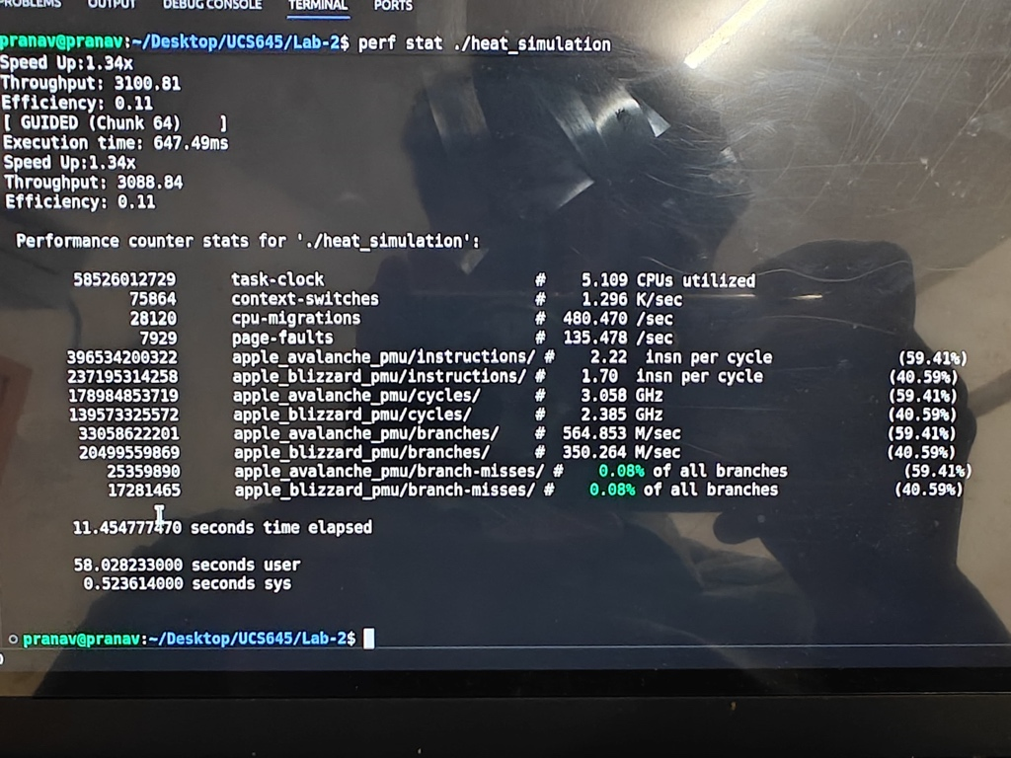
1. Resource Utilization:-
- Parallel Efficiency: The system achieves a wider parallel distribution with 5.109 CPUs utilized over the 11.45-second elapsed time, actively spreading the grid temperature calculations across multiple cores.
- Hybrid Execution: The workload is split much more evenly here between the Performance-cores (59.41% active time at 3.058 GHz) and Efficiency-cores (40.59% active time at 2.385 GHz).
2. Instruction Efficiency:-
- P-Core Performance: The Performance cores show a noticeably lower IPC of 2.22. For a mathematical simulation, this drop in instruction throughput points strongly to memory latency—the execution units are waiting for data to arrive from RAM rather than actively executing math.
- E-Core Lag: The Efficiency cores follow a similar trend with an IPC of 1.70, retiring fewer instructions per clock tick.
- Branch Prediction: Branch prediction remains flawless, with misses standing at a microscopic 0.08% across both P-cores and E-cores, meaning the grid-boundary checking loops are highly predictable.
3. Primary Bottlenecks:-
- Memory Bandwidth Saturation: The lower IPC (2.22 on P-cores) strongly suggests this 2D stencil computation is heavily Memory Bound. The cores are starved for data, constantly stalling on cache misses as they fetch neighboring grid temperatures from the main memory to compute the next state.
- High Migration & Scheduling Overhead: The system experienced a massive 28,120 CPU-migrations and 75,864 context-switches. The operating system is aggressively shuffling threads between the P-cores and E-cores (likely exacerbated by OpenMP's GUIDED scheduling dynamically handing out chunks). This rapid swapping wastes cycles, destroys cache locality, and is a primary reason the overall efficiency plummeted to 0.11.

